GEOBOARD NOTES ACTIVITIES 1 AND 2 AND REFERENCES
All the activities can be used in school and adapted for learners in different grades according to the learning objectives and time available.
*Teaching ideas. (1) With one geoboard for demonstration you will be able to use many of the ideas in these notes in your teaching. If learners do not have geoboards they can be asked to do the same tasks by joining points on dotty grids.
(2) Make a class set of geoboards so that learners can share one between two, work in pairs or small groups, then compare findings with other groups.
(3) Use and App https://www.mathlearningcenter.org/apps/geoboard
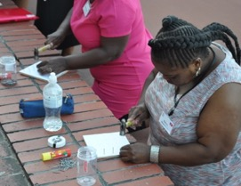
MAKING GEOBOARDS
Make your own geoboard. Use a paper square with the grid marked so that you knock in your nails accurately at the points of the grid.
Maybe this could be a project for a Design Technology class.
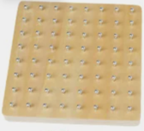
8 by 8 commercially produced
geoboard with nails and rubber bands

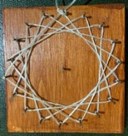
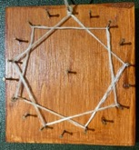
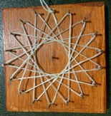
Three circular 18 pin geoboards showing multiples of 4, 5 and 7.
See Paths to the Stars
https://aiminghigh.aimssec.ac.za/path-to-the-stars/

ACTIVITY 1 TRIANGLES ON A 25 PIN GEOBOARD
DO Make a triangle on your geoboard.
TALK Look at the geoboards of the people around you.
Are their triangles the same as yours?
Try to make a different triangle from theirs so that your group can see many different triangles.
What is the same? What is different?
Can you sort them into sets of similar triangles and sets of congruent triangles?
RECORD Draw some of the different triangles on square dotty paper.
To cut down this task just draw ONE triangle from each set of congruent triangles.
Note the properties of each triangle :–
Is it… Right-angled?
Isosceles (two sides equal)?
Scalene(unequal sides)?
If you make a triangle that looks almost equilateral measure the edges. Is it equilateral?
What is its area?
What are its symmetries?
All the right angled isosceles triangles are enlargements of the small red triangle (number 1). How much bigger are they, that is, what are the scale factors of the enlargements?
How can we extend this activity?

Example: Set of 6 right angled isosceles triangles
All similar to each other  All enlargements of the red triangle no. 1  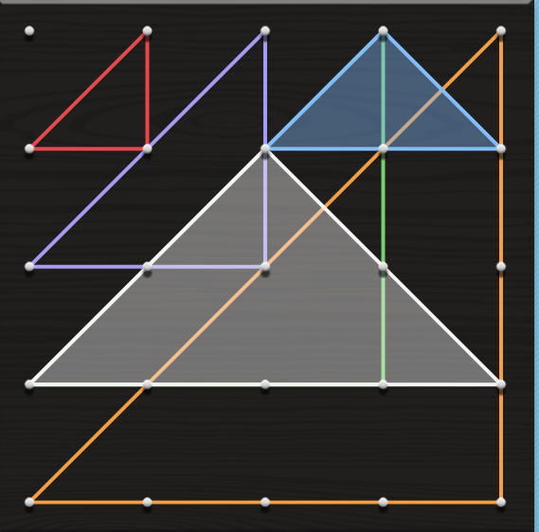  All have line symmetry  1  2  1  4  3  5  6 | Colour | Area | Lengths of Edges | Enlargements of red triangle 1
 |  |  |  | Linear scale factor | Area scale factor
 | 1 red
 | 2 blue
 | 3 lilac
 | 4 white
 | 3 green
 | 6 orange

SOLUTIONS | Colour | Area | Lengths of Edges | Enlargements of red triangle 1
SOLUTIONS |  |  |  | Linear scale factor | Area scale factor
SOLUTIONS | 1 red | ½ | 1, 1, √2 | 1 | 1
SOLUTIONS | 2 blue | 1 | √2, √2, 2 | √2 | 2
SOLUTIONS | 3 lilac | 2 | 2, 2, 2√2 | 2 | 4
SOLUTIONS | 4 white | 4 | 2√2, 2√2, 4 | 2√2 | 8
SOLUTIONS | 3 green | 4½ | 3, 3, 3√2 | 3 | 9
SOLUTIONS | 6 orange | 8 | 4, 4, 4√2 | 4 | 16
*You could give learners the blank table above and ask them to fill in the information. Select some of the columns if you don’t want the class to do them all.

ACTIVITY 2 QUADRILATERALS ON A 25 PIN GEOBOARD
DO Make a quadrilateral on your geoboard.
TALK about and RECORD your quadrilaterals, as for the triangles in Activity 1.

You might like to make a 9-pin geoboard for these activities and photocopy 9-dot grids for the learners.

References
Fithian, E. (2005) Activity 3 Geoboards www.home.ptd.net/~efithian/Geometry/Activity-03.html
Furner M.J. & Marinas C.J.(2011) Geoboards to Geogebra: moving from the concrete to the abstract in geometry. Proceedings of the Twenty-third Annual International Conference on Technology in Collegiate Mathematics, ISBN 0-321-68984-4, Copyright (C) 2012 by Pearson Education, Inc. www.archives.math.utk.edu/ICTCM/VOL23/S088/paper.pdf
Scandrett, Hilary ( 2008) Using Geoboards in Primary Mathematics. Australian Primary Mathematics Classroom, v13 n2 p29-32 2008 www.files.eric.ed.gov/fulltext/EJ802704.pdf
Take a ..Geoboard http://nrich.maths.org/10674
Free Web Ap https://itunes.apple.com/gb/app/geoboard-by-math-learning/id519896952?mt=8
or http://www.mathlearningcenter.org/web-apps/geoboard/
Making a Geoboard
Video http://www.youtube.com/watch?v=TEw61i1veOg
http://www.notimeforflashcards.com/2010/08/diy-geoboard.html
http://www.education.com/activity/article/geoboard/
http://www.feelslikehomeblog.com/2010/02/how-to-make-a-geoboard/
http://engagingtoddleractivities.wordpress.com/2010/05/07/homemade-geoboard/
Free Printable Geoboard Masters
http://nrich.maths.org/public/viewer.php?obj_id=6676&part=index
(http://eclectichomeschool.org/pdf/10x10dot.pdf
http://etc.usf.edu/clipart/galleries/math/geoboards.php
http://www.teachervision.fen.com/tv/printables/scottforesman/Math_3_TTT_7.pdf
Lessons with Geoboards
Video http://www.youtube.com/watch?v=ikaSgNDnrv0&feature=related
Video http://www.youtube.com/watch?v=OFucbbgLGZQ&playnext=1&list=PL351EA69AAEE764C3&index=18
http://nrich.maths.org/2883
Tips for Manipulatives – Geoboards & list of sample activities http://oame.on.ca/lmstips/files/Manips/Geoboards.pdf
http://mathcentral.uregina.ca/RR/database/RR.09.98/loewen2.3.html (angles, perimeter and area)
http://mathforum.org/trscavo/geoboards/geobd6.html
http://www.cut-the-knot.org/Curriculum/Geometry/Geoboard.shtml
Exploring Symmetry
http://images.pcmac.org/Uploads/OnslowCounty/OnslowCounty/Departments/DocumentsCategories/Documents/Geoboard%20Challenge%20-%204th.pdf
Exploring Area and Perimeter
http://www.mathplayground.com/geoboard.html
Worksheet http://www.mathinscience.info/public/cover_up/geoboard_activities.pdf
National Library of Virtual Manipulative Activities
(grades prek-2) http://nlvm.usu.edu/en/nav/frames_asid_277_g_1_t_3.html?open=activities
(grades 3-5) http://nlvm.usu.edu/en/nav/frames_asid_172_g_2_t_3.html?open=activities
(grades 6-8) http://nlvm.usu.edu/en/nav/frames_asid_282_g_3_t_3.html?open=activities
(making 3-d shapes) http://nlvm.usu.edu/en/nav/frames_asid_129_g_1_t_3.html?open=activities
(circular geoboard grades 3-5) http://nlvm.usu.edu/en/nav/frames_asid_127_g_2_t_3.html?open=activities
(circular geoboard grades 6-8) http://nlvm.usu.edu/en/nav/frames_asid_284_g_3_t_3.html?open=activities
(coordinate grid activities 3-5) http://nlvm.usu.edu/en/nav/frames_asid_166_g_2_t_3.html?open=activities
(coordinate grid activities 6-8) http://nlvm.usu.edu/en/nav/frames_asid_303_g_3_t_3.html?open=activities

