GEOBOARD NOTES ACTIVITIES 9 AND 10
ACTIVITY 9A HOW MANY SQUARES?
In this activity squares on different pins are different even when they are congruent.
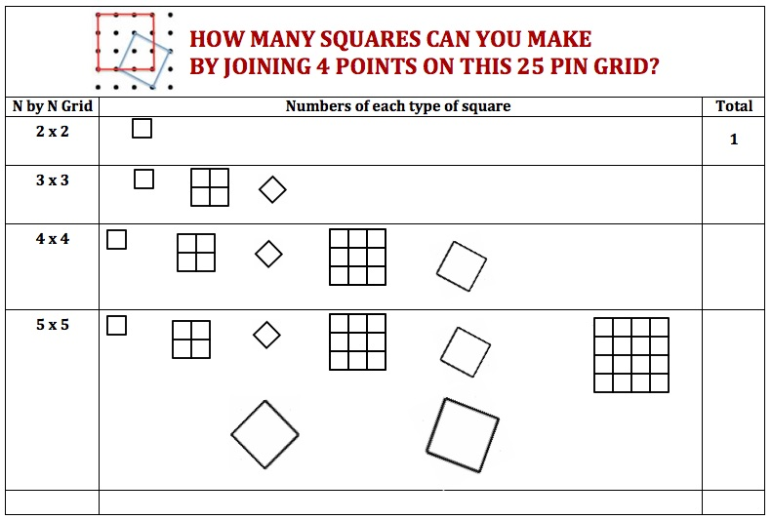
DO Look at your geoboard. How many pins are there on it?
The distance between the pins is ONE UNIT
How many different squares can you make?
TALK How many of each different type of square can you make?
RECORD The numbers on this chart.
*In problem solving it is important to work systematically as we do here. It often helps to work on simple cases first so start with a
4-pin board, then a 9-pin, then a
16-pin and then a 25-pin.
What about bigger grids?

Learners will enjoy the game: SQUARE IT http://nrich.maths.org/2526 . This game gives practice in strategic thinking, and can lead on to work on gradients, on parallel and perpendicular lines, and on Pythagoras Theorem.

ACTIVITY 9B HOW MANY SQUARES AND WHAT ARE THEIR AREAS?
Another system for recording the squares is to classify them using the notation (x, y) for the square that has vertices at (x,0) and (0,y). For example: the square shown in the diagram below is a (3, 1) square and it has area 10 square units.
The tables below can be used to record all the different squares according to their areas.
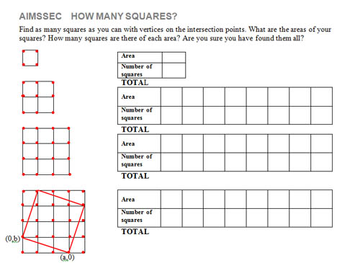

ACTIVITY 10 PROOF OF PYTHAGORAS THEOREM

Four congruent right angled triangles
+ the square on the shortest side
+ the square on the third side
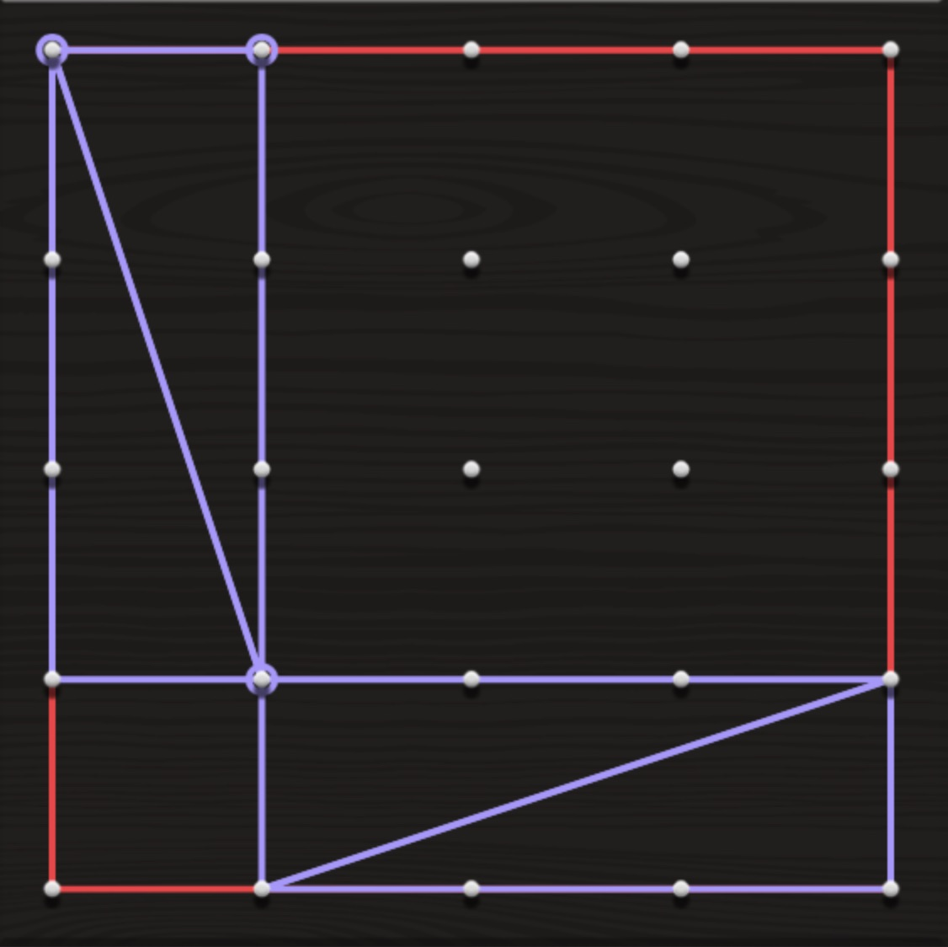
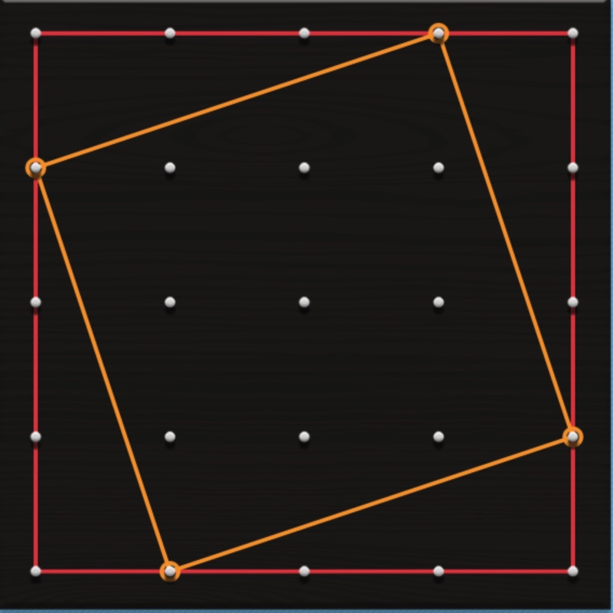

Four congruent right angled triangles
+ the square on the hypotenuse

P
THE AREAS OF THE OUTER RED SQUARE ARE THE SAME WITH DIFFERENET ARRANGEMENTS OF THE PIECES INSIDE.
TAKE AWAY THE AREAS OF THE FOUR CONGRUENT RIGHT ANGLED TRIANGLES AND EQUATE THE REMAINING AREAS.
DO Make these diagrams with rubber bands on your geoboard
TALK about the areas of the shapes
and about how you can prove Pythagoras Theorem using these diagrams.
Does the same reasoning apply if you draw the diagrams with the point P anywhere on the edge of the outer square (not on one of the pins) so the sides are not integer lengths, or perhaps not a real lengths, for example lengths √2 and (4 - √2)?
RECORD Write down your proof of Pythagoras Theorem based on these diagrams.

SOLUTION TO ACTIVITY 9 HOW MANY SQUARES?
