This INCLUSION AND HOME LEARNING GUIDE
suggests related learning activities for all ages from 4 to 18
on the theme of LAND AND SEA
Just choose whatever seems suitable for your group of learners

The original LAND AND SEA learning activity was designed for Years 10 to 13
LAND AND SEA STATISTICS
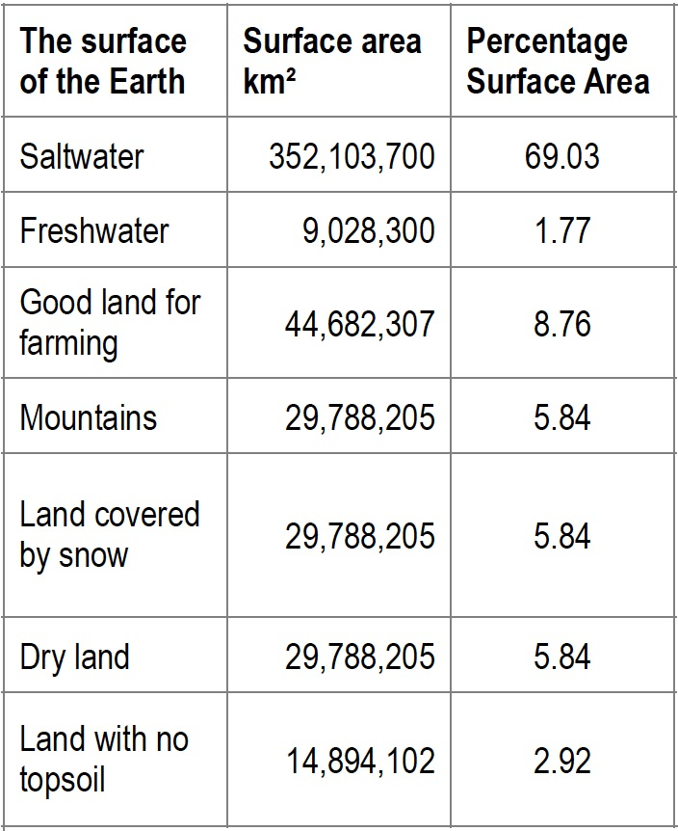
The table gives data on the land and sea covering the Earth’s surface.
(1) Explain how the percentage 69.03% of saltwater that makes up the Earth’s surface is calculated from these figures.
(2) How would you use this percentage to find the angle for saltwater for drawing a pie chart?
A pie chart and a frequency bar chart are given below.
(3) Which of the charts gives the best representation of the information in the table? Why?
(4) What can we learn from these statistics?

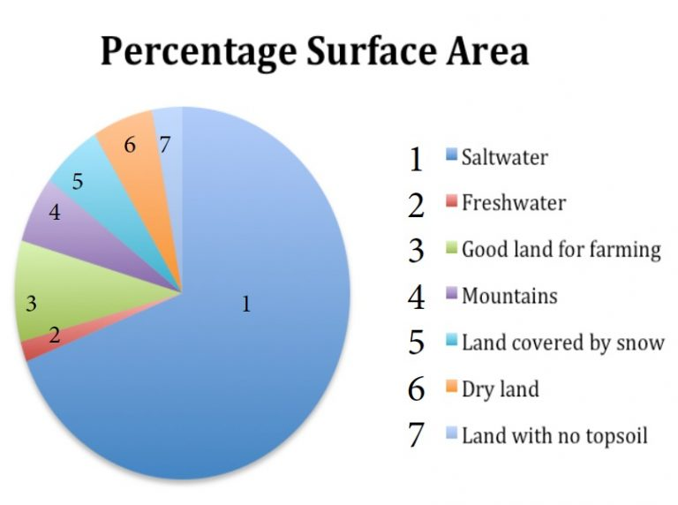
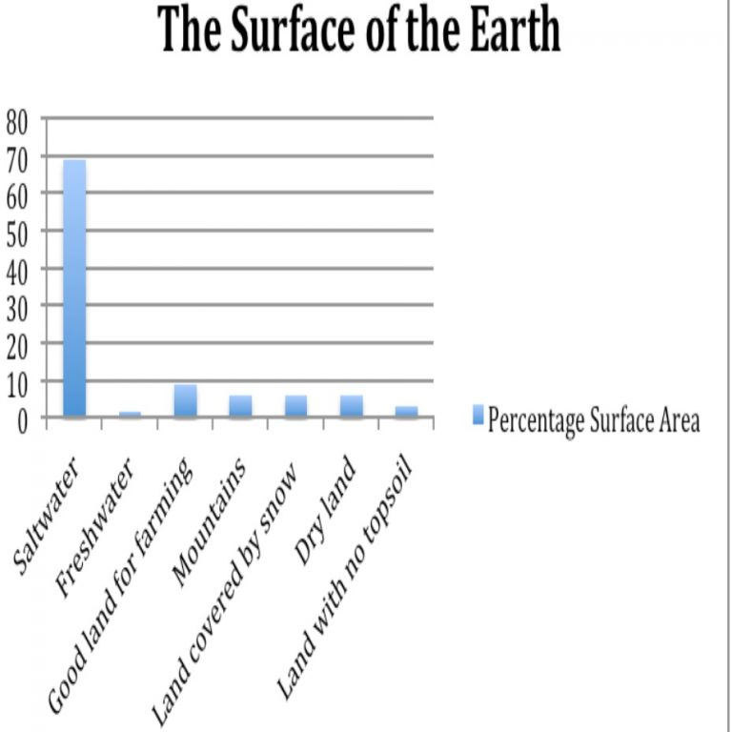

(5) What is the land like around where you live? What is it like in the rest of your country?
How does it affect your lives?
How does it affect economic development in your country?
This was originally a lesson option organised by the AIMSSEC-Bubbly Maths team for the GLOBAL MATHS AND SCIENCE LESSON.

HELP
First work out the actual total surface area.
To find the percentage of the earth’s surface covered by saltwater:
divide 352 103 700 sq km by the total surface area of the earth and multiply by 100.
(Note: the question does not ask anyone to do the calculation, just to say how it should be done.)

The next question is about the angle for the pie chart. The angles for the 7 sectors must add up to 360º and the angles must correspond to the percentages of each type of land.

NEXT
The table shows the percentages of land area, and percentages of total world population. Draw a double frequency bar chart to compare the two sets of figures.

Continent | Percentage of Total Land Area | Percentage of Total Population | Most populous  city (disputed)
Africa | 20.4% | 15% | Lagos, Nigeria
Antarctica | 9.2% | 0% | McMurdo Station, US
Asia | 29.5% | 60% | Shanghai, China
Australia | 5.9% | 0.4% | Sydney, Australia
Europe | 6.8% | 11% | Moscow, Russia
North America | 16.5% | 8% | Mexico City, Mexico
South America | 12.0% | 6% | São Paulo, Brazil

The statistics for the world’s biggest city are disputed (see Wikipedia references). Which of the following do you think best defines ‘biggest city’ and why?
- biggest land area;
- biggest population;
- biggest conurbation including other districts in the immediate area;
- another interpretation.
INCLUSION AND HOME LEARNING GUIDE
THEME: LAND AND SEA

Early Years

Click on this image to make it start or stop rotating. Ask the children what they notice. Stop the rotation at different places.

Locate on this image where you are on Planet Earth and talk about land and sea.

Are you far from the sea?

Say that the green is land and the blue is sea.

Is there more land than sea or more sea than land?

Lower Primary

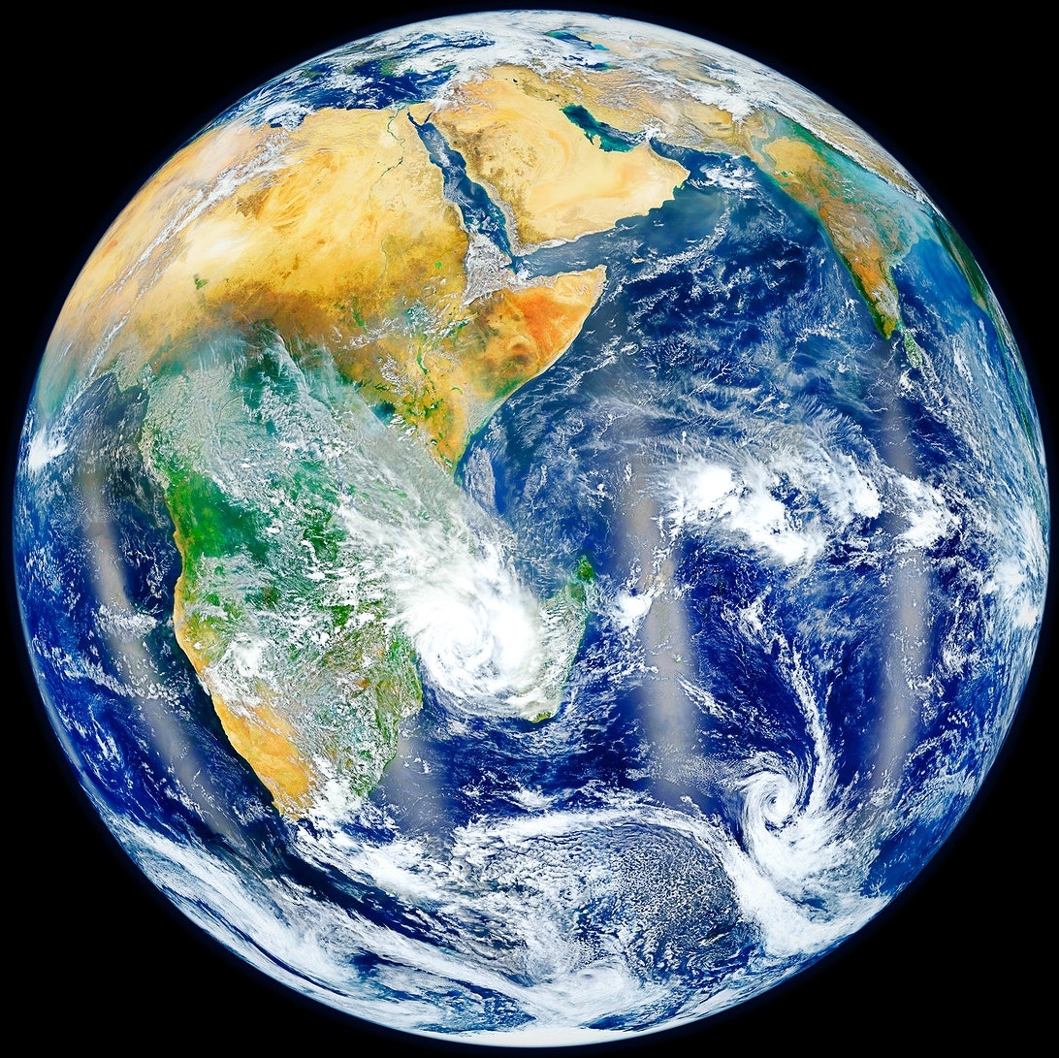
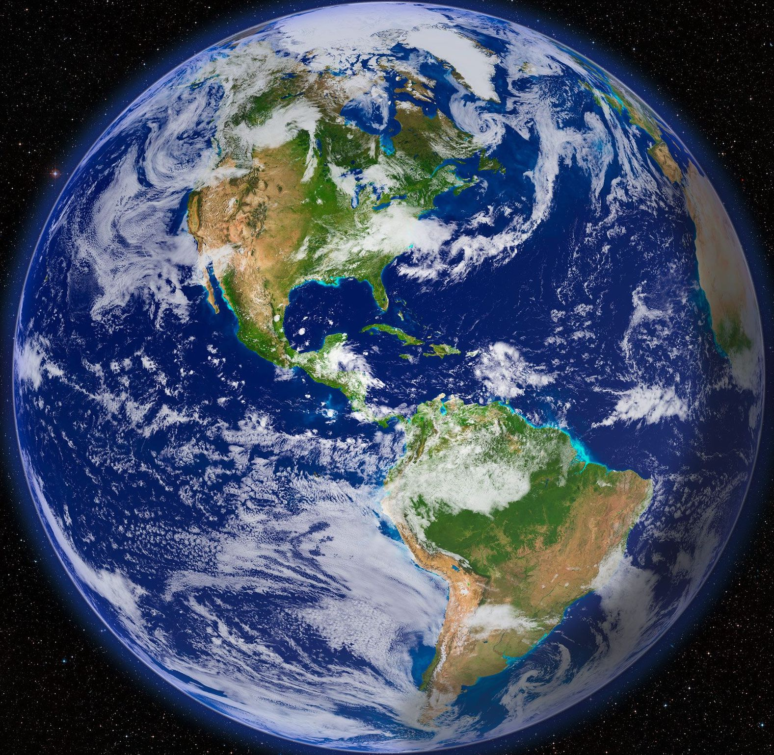
Look at these two photographs of the Earth taken from space and the rotating image below. Click on this image to make it start or stop rotating. Ask the children what they notice. Stop the rotation at different places.

Locate on the images where you are on Planet Earth and talk about land and sea.

Are you far from the sea?

The green is land and the blue is water on the spinning picture. Is there more land than water or more water than land?

Look at the pie chart below that shows how the Earth is covered by land and water.

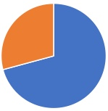
Which part of the pie chart do you think shows the land and which part shows water? Why?

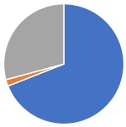

This pie chart shows the freshwater, saltwater and land on the Earth.

Which part of the pie chart do you think shows the freshwater, which part shows the saltwater and which part shows the land?

Upper Primary and Lower Secondary

Look at these two photographs of the Earth taken from space and the rotating image below. Click on this image to make it start or stop rotating. Ask the learners what they notice. Stop the rotation at different places.

Locate on this image where you are on Planet Earth and talk about land and sea.

Are you far from the sea?

Locate the continents (large land masses): Africa, Antarctica, Asia, Australia, Europe, North America, South America.

Match the sectors in this pie chart to the continents.

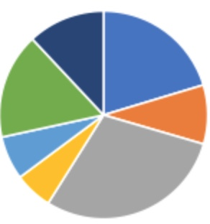
Continents  (large land masses) | Percentage of the land area
Africa | 20.4
Antarctica | 9.2
Asia | 29.5
Australia | 5.9
Europe | 6.8
North America | 16.5
South America | 12

,

SOLUTION
In this pie chart the water on the surface of the Earth is represented by the blue sector and the land is represented by the orange sector.

In this pie chart the saltwater on the surface of the Earth is represented by the blue sector, the freshwater is represented by the orange sector, and the land is represented by the grey sector.

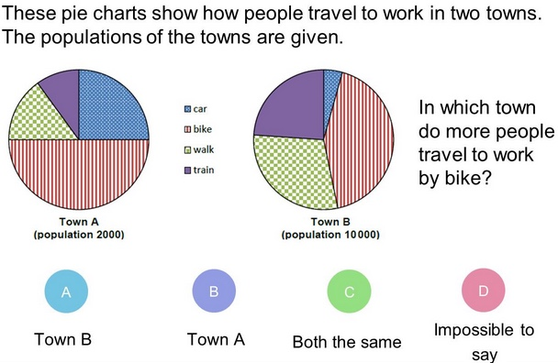
Upper Secondary

Start with the diagnostic question.

Then work through the questions on pages 1 and 2, in a group if possible so that you can discuss the questions and the ideas.

You are asked HOW to do the calculations and you don’t actually need to do them.

Key questions

What is a percentage?
You are asked how to calculate a percentage, how do you usually do that?

You are asked how to calculate an angle for a pie chart, how do you usually do that?

What do you notice when you look at this pie chart?

What do you notice when you look at this bar chart?

Why do this activity?
This activity gives learners the experience of reading and interpreting data given in different forms. The data is given in a simple form and relevant to the real world so that learners can have the experience of discussing the significance of the data, and relating it to other school subjects and to issues that affect society.
Learning objectives
In doing this activity students will have an opportunity to:
- practise reading and interpreting data;

gain a better understanding of pie charts and bar charts, and their uses.

Generic competences

In doing this activity students will have an opportunity to :

learn more about land use, land area and population statistics for the whole planet;

experience relating school mathematics to the real world and to other school subjects.

SOLUTION
(1) To find the percentage of the earth’s surface covered by saltwater divide the actual surface area 352 103 700 sq km by the total surface area of the earth and multiply by 100. (Note: the question does not ask anyone to do the calculation, just to say how it should be done.)
(2) To find the angle for drawing a pie chart work out 69.3 × 360/100 to give 249.5º. (Again the question does not ask anyone to do the calculation.)
(3) Which of the charts gives the best representation of the information in the table? Why?
The answer depends on what information is important to you.
The pie chart makes it easier to compare areas, to see at a glance which are larger and which are smaller areas and to compare the sizes
The bar chart makes it easier to read off the approximate areas in sq km, although in this case, because the saltwater area is so very much larger than anything else the readings cannot be very accurate.
(4) What can we learn from these statistics?
This is a question for class discussion.
(5) What is the land like around where you live?
What is it like in the rest of your country?
How does it affect economic development in your country?
How does it affect your lives?
These questions are for discussion and perhaps as a basis for learners to look up information about their own country online.

The questions also link the mathematics they learn with other school subjects such as geography, science and economics and prepare them for adult life and citizenship.
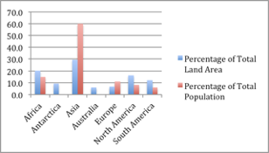
NEXT SOLUTION

Follow up

Drinking Water https://aiminghigh.aimssec.ac.za/years-6-10-drinking-water/

A Richer World https://aiminghigh.aimssec.ac.za/years-9-12-a-richer-world/

Go to the AIMSSEC AIMING HIGH website for lesson ideas, solutions and curriculum links: http://aiminghigh.aimssec.ac.za
Subscribe to the MATHS TOYS YouTube Channel
https://www.youtube.com/c/mathstoys
Download the whole AIMSSEC collection of resources to use offline with
the AIMSSEC App see https://aimssec.app Find the App on Google Play.

Note: The Grades or School Years specified on the AIMING HIGH Website correspond to Grades 4 to 12 in South Africa and the USA, to Years 4 to 12 in the UK and school years up to Secondary 5 in East Africa.
New material will be added for Secondary 6.
For resources for teaching A level mathematics (Years 12 and 13) see https://nrich.maths.org/12339
Mathematics taught in Year 13 (UK) & Secondary 6 (East Africa) is beyond the SA CAPS curriculum for Grade 12
 | Lower Primary  Approx. Age 5 to 8 | Upper Primary  Age 8 to 11 | Lower Secondary  Age 11 to 15 | Upper Secondary  Age 15+
South Africa | Grades R and 1 to 3 | Grades 4 to 6 | Grades 7 to 9 | Grades 10 to 12
East Africa | Nursery and Primary 1 to 3 | Primary 4 to 6 | Secondary 1 to 3 | Secondary 4 to 6
USA | Kindergarten and G1 to 3 | Grades 4 to 6 | Grades 7 to 9 | Grades 10 to 12
UK | Reception and Years 1 to 3 | Years 4 to 6 | Years 7 to 9 | Years 10 to 13

