HOW MANY SUMS?
Put positive whole numbers into the boxes to make the sum correct? Here is one way to do it.
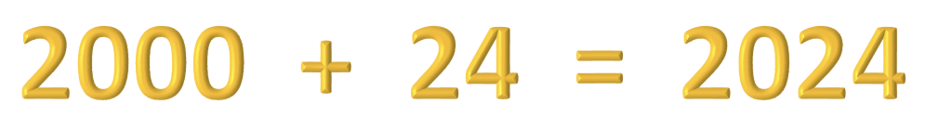

How many other ways can you put positive whole numbers into the boxes to make the sum correct?
Explain your answer.

Now answer the same question for the year you were born.

HELP

What would the ? represent in 5 + ? = 2024

What other numbers could you use instead of 5?
Now answer the question: How many ways can you put positive whole numbers into the boxes to make the sum correct?
So how many ways can you do it apart from 1 + 2023 = 2024 and 5 + 2019 = 2024?
Explain your answer.

NEXT
The answer is 2024, what is the question?
This time make up your own questions that have the answer 2024, work out the solution and then exchange one of your questions with your partner. You must do your partner’s question and your partner must do your question.

NOTES FOR TEACHERS
SOLUTION
As there are only two boxes we are looking for pairs of positive whole numbers that add up to 2021. Possibilities are:
1 + 2023
2 + 2022
3 + 2021 …
…
2023 + 1
so there are exactly 2023 different ways to put positive whole numbers into the boxes to make the sum correct.

Why do this activity?
This is a ‘quickie’ that could be a lesson starter. It is important for learners to think mathematically and to explain their reasoning. This gives learners practice in doing that while reinforcing their number sense.
Learning objectives
For learners to solve a non-standard problem and be able to explain their reasoning.

DIAGNOSTIC ASSESSMENT This should take about 5–10 minutes.
Write the question on the board, say to the class:

“Put up 1 finger if you think the answer is A, 2 fingers for B, 3 fingers for C and 4 for D”.

Notice how the learners respond. Ask a learner who gave answer A to explain why he or she gave that answer. DO NOT say whether it is right or wrong but simply thank the learner for giving the answer.
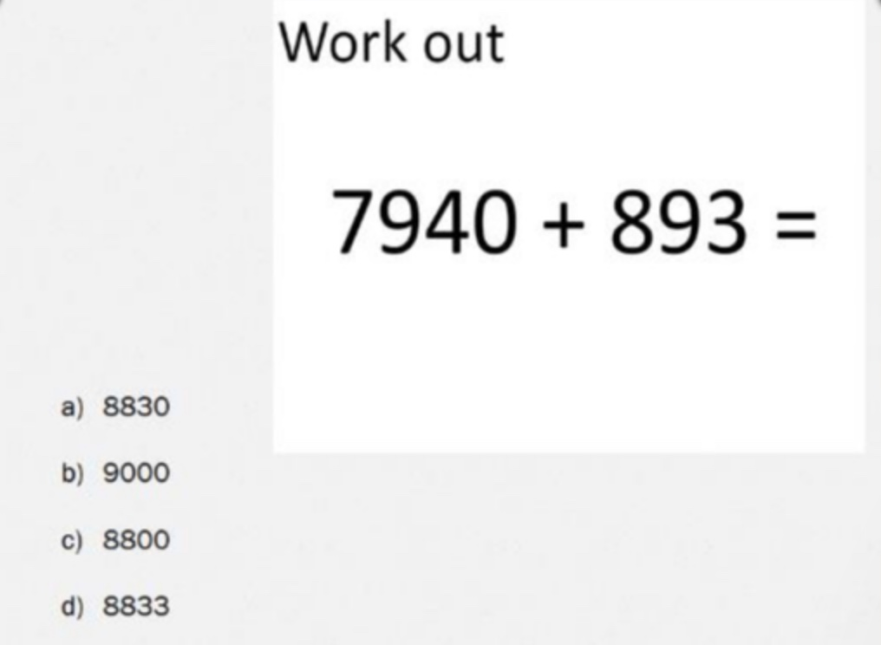

https://diagnosticquestions.com

It is important for learners to explain the reasons for their answers. Putting thoughts into words may help them to gain better understanding and improve their communication skills.

Then do the same for answers B, C and D. Try to make sure that learners listen to these reasons and try to decide if their own answer was right or wrong.

Ask the class to vote for the right answer by putting up 1, 2, 3 or 4 fingers. Notice if there is a change and who gave right and wrong answers.
D is the correct answer. You might reason :
“7940 is 60 LESS THAN 8000 so the answer is 60 LESS THAN 8893”
Possible misconceptions: A. Learners may have done some mental arithmetic to work out that the answer is 8 thousand 8 hundred and thirty something and stopped there. This seems to show the learner did not add the units digit first.
B. Reveals that the learner had no idea how to add the numbers.
C. As with A. learners may have done some mental arithmetic to work out that the answer is 8 thousand 8 hundred and something and stopped there.
https://diagnosticquestions.com

Suggestions for teaching

NOTE You can change this question to use any total.

Write the question on the board at the start of the lesson and encourage learners to work individually for a few minutes and then to talk about their answers with their partner. Then ask learners to explain their answers to the class.

Key questions

What would the ? represent in 5 + ? = 2024

What other numbers could you use instead of 5?

You have quite a lot of possible answers there. Can you put your answers in order?

Can you explain how you added up those two numbers?

What would you get if you subtracted 25 from 2024? How did you work that out?

How many different whole numbers can you subtract, one at a time, from 2024 and still get a positive answer?

Follow up

The answer is 2024 but what is the question?

https://aiminghigh.aimssec.ac.za/the-answer-is-2024-what-is-the-question/

Go to the AIMSSEC AIMING HIGH website for lesson ideas, solutions and curriculum links: http://aiminghigh.aimssec.ac.za
Subscribe to the MATHS TOYS YouTube Channel
https://www.youtube.com/c/MathsToys/videos
Download the whole AIMSSEC collection of resources to use offline with
the AIMSSEC App see https://aimssec.app or find it on Google Play.

Note: The Grades or School Years specified on the AIMING HIGH Website correspond to Grades 4 to 12 in South Africa and the USA, to Years 4 to 12 in the UK and school years up to Secondary 5 in East Africa.
New material will be added for Secondary 6.
For resources for teaching A level mathematics (Years 12 and 13) see https://nrich.maths.org/12339
Mathematics taught in Year 13 (UK) & Secondary 6 (East Africa) is beyond the SA CAPS curriculum for Grade 12
 | Lower Primary  Approx. Age 5 to 8 | Upper Primary  Age 8 to 11 | Lower Secondary  Age 11 to 15 | Upper Secondary  Age 15+
South Africa | Grades R and 1 to 3 | Grades 4 to 6 | Grades 7 to 9 | Grades 10 to 12
East Africa | Nursery and Primary 1 to 3 | Primary 4 to 6 | Secondary 1 to 3 | Secondary 4 to 6
USA | Kindergarten and G1 to 3 | Grades 4 to 6 | Grades 7 to 9 | Grades 10 to 12
UK | Reception and Years 1 to 3 | Years 4 to 6 | Years 7 to 9 | Years 10 to 13

