ACTIVITY 1 – MAKING POLYHEDRA FROM ROULEAUX SHAPES
Resources: scrap card, compasses, protractors, rulers, glue (quick setting glue preferable), staplers.
Vocabulary: rouleaux shape, tetrahedron, octahedron, cube, icosahedron, dodecahedran, buckyball, truncated icosahedron.
Curriculum links: Recognises similarities and differences between different polyhedra. Uses a pair of compasses, ruler and protractor to construct geometric figures accurately. Makes models of geometric solids.
INTRODUCING THE ACTIVITY
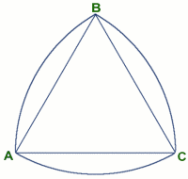
Look at a 20 cent coin. Can you see that it has nine straight edges and round bits outside those edges? Perhaps there are nine edges for the nine South African provinces.
Using scrap card make some rolling triangles like this. The outer curves do not form a circle. The centre of each arc is a vertex of the triangle and the radius of each arc is the length of the edge of the triangle. This shape is called a rouleaux shape because it actually rolls and many countries have coins shaped like this which can be used in slot machines just like circular coins. These shapes can be used to construct 3D solids with the rounded bits as flaps. You could make the outer edge a circle but then you get bigger flaps which are quite ugly in the final model.
Demonstrate to the class how to make a tetrahedron by sticking the flaps together. The model is much easier to assemble with the flaps sticking out rather than with the flaps inside. To hold the flaps together, either use rubber bands or glue the flaps and staple them to held them while the glue dries.
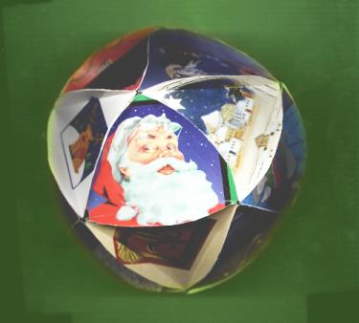
GROUP ACTIVITY
Make lots of these rolling triangles. The rolling triangles must be accurately constructed. The first one can be used as a template for the rest so learners just draw around the first one to make the others. Use old greetings cards or food packets from the kitchen and paint them). Accurately construct an equilateral triangle, measuring the angles with a protractor. Using a pair of compasses draw arcs with centres at the vertices of the triangle so that the radius of each arc is the length of the edge of the triangle. Score along the edges of the equilateral triangles.
Make regular solids (tetrahedra, octahedra, icosahedra) by sticking the flaps together. They look good either way: both with the flaps projecting outwards or inwards. Your class could make some models to hang from the ceiling in your classroom.
You can also make a dodecahedron using 12 rolling pentagons. A rolling pentagon is made in a similar way starting with a regular pentagon (angle of 108º).
ACTIVITY 2: MAKING A BUCKY BALL - A CLASS PROJECT
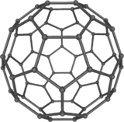
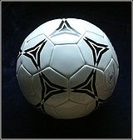
You can even make a buckyball (football shape) from scrap card using this method. It is a big project but an exciting one. You will need 12 regular pentagons and 20 regular hexagons. If you make a buckyball with edge length 10 centimetres it is quite spectacular.
Each learner can accurately make a polygon with flaps (pentagon or hexagon) and they can even decorate their polygons. Then the class can assemble them into bucky balls.
Make 2 templates. First draw a regular pentagon accurately with angles of 108 degrees and then add the flaps. If you are making a model with edge length approximately 10 centimetres then you can use a dinner plate to mark the curved edges. Cut out your template. Score along the straight edges of the pentagon and crease along the score lines. Then draw a regular hexagon accurately with angles of 120 degrees and then add flaps. Score along the straight edges of the hexagon and crease along these score lines. You can then draw around the templates to make the other faces of the buckyball but all the faces must be made accurately. These flaps should not be as big as for the rouleaux shapes.
Build your buckyball by attaching 6 hexagons around each pentagon making sure that at every vertex of the solid there are two hexagons and one pentagon. Use quick setting glue and staple the flaps together to hold them while the glue is setting.
How many faces, edges and vertices does the buckball have?
The word ‘truncated’ means cut off. Compare your buckyball to an icosahedron and try to explain why the buckyball has the name ‘truncated icosahedron’.
To make the buckyball you have used hexagons and pentagons. Is it possible to make a solid using only hexagons? Explain your answer.
Do some research on the internet to find out about carbon atoms and buckyballs. Also find out about the inventor Buckmaster Fuller and geodesic domes.
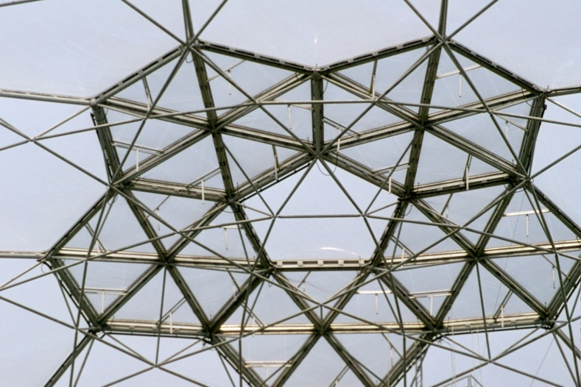
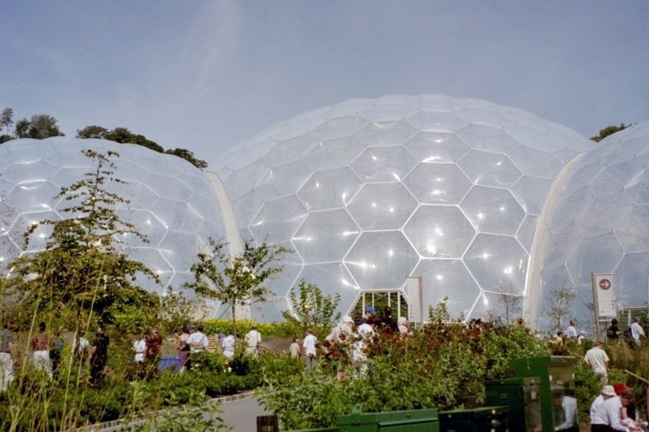
Geodesic Biodomes
Eden Project UK.
ACTIVITY 3 – EULER’S FORMULA
Resources: A selection of polyhedra.
Vocabulary: tetrahedron, octahedron, cube, icosahedron, dodecahedran, buckyball, truncated icosahedron, cuboid, square based pyramid, triangular prism.
Curriculum links: Recognises, visualises and names geometric figures and solids including: the Platonic solids and regular and irregular polygons and polyhedra. Makes models of solids in order to investigate and compare their properties.
INTRODUCING THE ACTIVITY
For this activity you need to have the polyhedra available that the class has already made using the ideas in this book.
GROUP ACTIVITY
Study as many polyhedra as you can find and fill in the following table. You should have recorded facts such as the number of faces, edges and vertices of some of these polyhedra when you were doing other activities from this book. Count them now if you need to do so. Add up the number of faces and edges. What do you notice?
Name of polyhedron | Number of faces  F | Number of edges  E | Number of vertices  V
Cube
Tetrahedron
Octahedron
Icosahedron
Dodecahedron
Buckyball
Square based pyramid
Triangular prism
Cuboid
Note for the teacher: Euler’s formula F+V-E=2 holds for all polyhedra. The formula is of fundamental importance in the study of topology, an important branch of mathematics. The number 2 is Euler’s constant in 3D. Networks of vertices, edges and faces in other dimensions, and on surfaces of solids with holes in them, have other Euler constants.

